

STUDENTS INTERNSHIP REPORT
&
FEEDBACK FORM
DEPARTMENT OF INFORMATION TECHNOLOGY
Submitted by

NAME:S.B.KOWSHIKKA Reg no:720823106046

INDUSTRY NAME : EMGLITZ TECHNOLOGIES,

(address) SAIBABA COLONY,COIMBATORE

DATE : 28/12/2024 To 18/01/2025

No. of days : 22

HINDUSTHAN INSTITUTE OF TECHNOLOGY
(An Autonomous Institution) COIMBATORE
ACADEMIC YEAR 2024-2025



HINDUSTHAN INSTITUTE OF TECHNOLOGY
Approved by AICTE, New Delhi, Accredited with ‘A’ Grade by NAAC
Coimbatore 641032.

Department of Information Technology

22TP708 – INTERNSHIP/INPLANT TRAINING REPORT

NAME OF THE INDUSTRY : EMGLITZ TECHNOLOGIES LTD
& ADDRESS SAIBABA COLONY,COIMBATORE

DATE : 28/12/2024 to 18/01/2025

ACADEMIC YEAR : 2024 - 2025

SUBMITTED BY:
Name of the Student: Kowshikka S B
Register Number: 720823106046
Year & Section: II YEAR-A
Department of Information Technology



HINDUSTHAN INSTITUTE OF TECHNOLOGY
Approved by AICTE, New Delhi, Accredited with ‘A’ Grade by NAAC
Coimbatore 641032.

BONAFIDE CERTIFICATE

This is to certify that the internship work submitted in partial fulfillment of the requirement for the award of the Degree of Information Technology, is the Bono-fide record of the internship work done KOWSHIKKA S B-720823106046 during the academic year 2024 - 2025.

INTERNSHIP COORDINATOR | HEAD OF THE DEPARTMENT
Mrs.V.Umashankari M.E., | Dr.M.Duraipandian M.E.,Ph.D.
Assistant Professor | Professor and Head
Department of Information Technology, | Department of Information Technology,
Hindusthan Institute of Technology, | Hindusthan Institute of Technology,
Coimbatore-641032 | Coimbatore-641032

Submitted for the Practical Examination of the Anna University conducted on
…………………………….

Internal Examiner External Examiner

ACKNOWLEDGEMENT

I am writing this final evaluation report as part of the Internship Program of the Functional Departments. This report includes of Emglitz Technologies Pvt Ltd, Coimbatore.
It has been a great challenge but a plenty of learning and opportunities to gain huge knowledge on the way writing this report. I express my sincere thanks to Dr.M.Duraipandian M.E.,Ph.D., our
amazing HOD of Information Technology department, who seemed to be with us always; and prepared to give us feedback and guidelines whenever we needed it.
I would also like to express my Gratitude to Mr.Gowtham, Head, training & development, Roots Industries India Ltd. I also thank Mrs.Gokila, Director HR, Roots Industries India Ltd for recognizing my presence during the training period.
I would also thank all the staff-members of the Emglitz Technologies Pvt Ltd whom I met in this time period for all the feedback and help which they provided to me.

JAVA PROGRAMMING
JAVA INTERNSHIP REPORT

INTERNSHIP REPORT ON JAVA
A brief explanation of JAVA programming language and its real-time applications

JAVA
Java is an object oriented programming language developed by Sun Microsystems in early 1990 by developers James Gosling, Mike Sheridan and Patrick Naughton. In 1991 James Gosling and his friends formed a team called Green Team to further work on this project. The original idea was to develop this programming language for digital devices such as television, set-top box, remote etc. Later this idea was dropped and Java is developed for internet programming
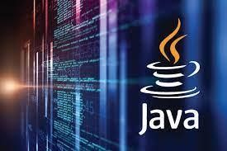
Original and first version of Java:
JDK first version alpha & beta was released in 1995 by Sun Microsystems.

Features of Java Programming Language
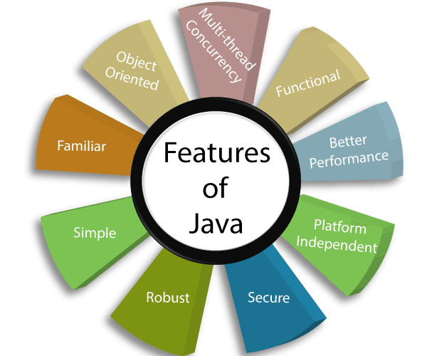
How is Java platform independent?

The meaning of platform-independent is that the java compiled code (byte code) can run on all operating systems. Three special things are introduced in java that JDK, JVM, JRE…

JDK (Java Development Kit)
JDK is a superset of JRE, it contains everything that JRE has along with development tools such as compiler, debugger etc.
- JDK stands for Java Development Kit. To install Java on your system, you need to first install JDK on your system.
- JDK contains the tools that you need, in order to write and execute java programs.
- JDK consists of Private JRE, JVM, compiler, Java application launcher, Applet viewer, etc. It also provides the Standard Edition (SE) of java API.
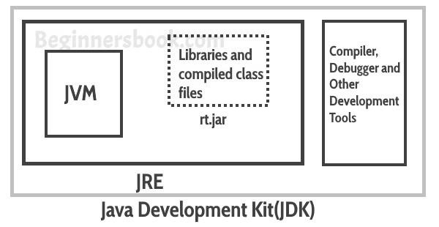

Features of JDK
- The JDK comes with a complete Java Runtime Environment (JRE), that is different from the regular JRE that the reason it is usually called a private runtime so we can say that it includes all the features that JRE has.
- It has all the java development tools such as compiler, JVM, JRE, debugger etc.
- You need JDK in order to write and run java program.
- JDK supports multiple platforms and can be installed on Windows, Mac and other operating systems.

JRE (Java Runtime Environment)
JRE is the environment within which the java virtual machine runs. JRE contains Java virtual Machine (JVM), class libraries, and other files excluding development tools such as compiler and debugger.
Which means you can run the code in JRE but you can’t develop and compile the code in JRE.
- JRE stands for Java Runtime Environment. It provides runtime environment for java applications.
- You need JRE in order to run java programs. If you are not a developer and not writing java programs, you do not need JDK but you still need JRE to run java programs.
- All the JDK already comes with JRE so you do not need to download and install it separately.
- JRE contains set of libraries and other files that JVM uses at runtime.
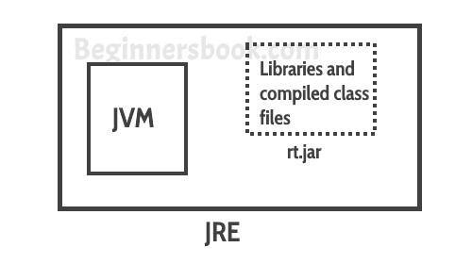

Features of JRE
- JRE contains set of libraries and other tools that JVM needs at runtime.
- You can easily run any java program on JRE but you need JDK to write and compile java programs.
- JRE contains libraries that are required for integrations such as Java Database Connectivity (JDBC), Java Naming and Directory Interface (JNDI), Remote Method Invocation (RMI) etc.

JVM (Java Virtual Machine)
Java is a high-level programming language. A program written in high level language cannot be run on any machine directly. First, it needs to be translated into that particular machine language. The java compiler does this thing, it takes java program (.java file containing source code) and translates it into machine code (referred as byte code or .class file).
Java Virtual Machine (JVM) is a virtual machine that resides in the real machine (your computer) and the machine language for JVM is byte code. This makes it easier for compiler as it has to generate byte code for JVM rather than different machine code for each type of machine. JVM executes the byte code generated by compiler and produce output. JVM is the one that makes java platform independent.

Simple Java Program
This is a very basic java program that prints a message “This is my first program in java”.
public class HelloJava {

public static void main(String[] args)
{
System.out.println("hello Java");
}

}

Output; hello Java

Public class HelloWorld
first line of our java program. Every java application must have at least one class definition that consists of class keyword followed by class name. When I say keyword, it means that it should not be changed, we should use it as it is. However, the class name can be anything.
I have made the class public by using public access modifier, I will cover access modifier in a separate post, all you need to know now that a java file can have any number of classes but it can have only one public class and the file name should be same as public class name.

Public static void main (String args [])
public: This makes the main method public that means that we can call the method from outside the class. static: We do not need to create object for static methods to run. They can run itself. void: It does not return anything.
main | : It is the method name. This is the entry point method from which the JVM can run
your program.
(String [] args) |  | : Used for command line arguments that are passed as strings. We will cover
that in a separate post.

HOW TO USE SCANNER CLASS

program
public class Scannerexample {

public static void main(String[] args)
{

Scanner in=new Scanner(System.in);
System.out.println("enter a name");
String name=in.next();
System.out.println("name is :"+name);
}

}

Output;
Enter a name
Java Name is java

Input Types
In the example above, we used the nextInt (), next (), nextByte (), nextFloat (), nextDouble () method, which is used to read Strings. To read other types, look at the table below:

Java application
- Technology is constantly going through an evolution and so are the languages that are used to develop them. Java is one of the popular programming language having n number of applications. Through this blog, I will be listing down the top 10 applications of Java.
Desktop GUI Applications

- Mobile Applications
- Enterprise Applications
- Scientific Applications
- Web-based Applications
- Embedded Systems
- Big Data Technologies
- Distributed Applications
- Cloud-based Applications
- Web servers and Application servers
- Software Tools
- Gaming Applications

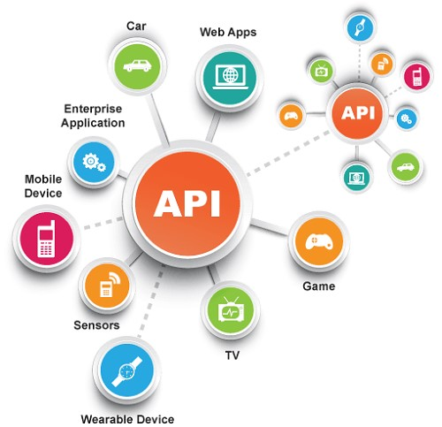

JAVA IS An OBJECTED ORIENTED PROGRAMMING LANGUAGE (OOPS CONCEPT)
Object means a real-world entity such as a pen, chair, table, computer, watch, etc. ObjectOriented Programming is a methodology or paradigm to design a program using classes and objects. It simplifies software development and maintenance by providing some concepts:
o Object o Class o Inheritance o Polymorphism o Abstraction o Encapsulation

Object
Any entity that has state and behaviour is known as an object. For example, a chair, pen, table, keyboard, bike, etc. It can be physical or logical.
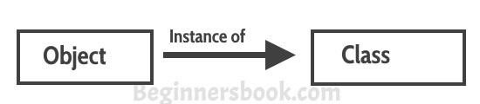

Class
Collection of objects is called class. It is a logical entity.
A class can also be defined as a blueprint from which you can create an individual object. Class doesn't consume any space.

Polymorphism
Polymorphism is an important OOP concept; it means the ability to take many forms. For Example, an operation exhibits different behaviour in different situations. The behaviour depends on the type of data used in operation. For Example, in the operation of addition, the operation generates a sum for two numbers. If the operands are strings, then a third-string is produced by the operation by concatenation.
The figure below demonstrates that a single function name can be used to handle the different numbers and different types of arguments.
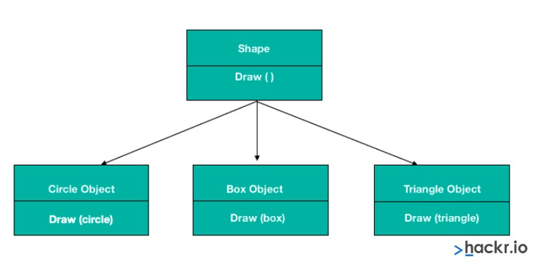
In polymorphism, objects having different internal structures can share the same external interface; it means that a class of operation may be accessed in the same manner even though actions with each operation may differ. Inheritance extensively uses the concept of polymorphism.
Polymorphism can be achieved in two ways:
- Method overloading
- Method overriding
Method declaration
package methods;

public class Add1 {

Add1()
{
System.out.println("java");
}
static int add(int a, int b)
{
int c=a+b;
return c;
}
}
package methods;

public class Constructor {

public static void main(String[] args)
{
Add1 sum=new Add1();

System.out.println(sum.add(20,10));

}

} Output; java 30

Inheritance
When one object acquires all the properties and behaviours of a parent object, it is known as inheritance. It provides code reusability. It is used to achieve runtime polymorphism. They are five types
o Single inheritance o Multiple inheritance o Multilevel inheritance o Hybrid inheritance o Hierarchal inheritance
package shruthi;
class employee1 //parent class
{
double salary=700000;

}

public class Inherit extends employee1 //child class
{
int bonus=10000;
public static void main(String[] args)
{
Inherit emp=new Inherit();

System.out.println("employee’s salary is.. "+emp.salary);
System.out.println("bonus is "+emp.bonus);

}

}
Output; employee’s salary is... 700000.0 bonus is 10000

Abstraction
Hiding internal details and showing functionality is known as abstraction. For example phone call, we don't know the internal processing.

Encapsulation
Binding (or wrapping) code and data together into a single unit are known as encapsulation. For example, a capsule, it is wrapped with different medicines.
A java class is the example of encapsulation. Java bean is the fully encapsulated class because all the data members are private here. Example program
package methods;

public class EncapsulationDemo {

private int empId; private String empName;
private int empAge;

public int getEmpId(
{
return empId;
}
public String getEmpName()
{
return empName;
}
public int getEmpAge()
{
return empAge;
}
public void setEmpName(String newValue)
{
empName=newValue;
}
public void setEmpAge(int newValue){ empAge = newValue;
}
public void setEmpId(int newValue){ empId = newValue;
}
}

package methods;
public class Encapsulation {

public static void main(String[] args)
{
EncapsulationDemo caps=new EncapsulationDemo();
caps.setEmpName("shruthi"); caps.setEmpId(4411);
caps.setEmpAge(20);
System.out.println("employ name is..."+caps. getEmpName ());
System.out.println("employ age is..."+caps. getEmpAge ());
System.out.println("employ id is..."+caps. getEmpId ());
}

}

Output;
employ name is...shruthi employ age is...20 employ id is...4411

1.Enterprise Applications
- Java EE (Enterprise Edition) is widely used in large-scale enterprise applications. It supports building robust, scalable, and secure applications.
- Examples:
  - Banking Systems: Many banks use Java to handle complex transactions, data management, and security features.
  - Customer Relationship Management (CRM) Systems: Java is used to develop systems that help businesses manage customer data and interactions.

2. Web Development
- Java for Web Apps: Java, especially through frameworks like Spring, JSF (JavaServer Faces), and Hibernate, is extensively used to build dynamic web applications.
- Examples:
  - E-commerce Websites: Online shopping platforms, where Java handles back-end processing, product catalogs, and payment processing.
  - Social Media Platforms: Social networks, forums, and content management systems often leverage Java for their back-end systems.

3. Mobile Applications
- Android Development: Java is the official language used for Android app development. Though Kotlin is gaining popularity, Java is still heavily used in creating Android applications.
- Examples:
  - Popular Android Apps: Apps like WhatsApp, Spotify, and Instagram used to be primarily developed with Java.
  - Mobile Games: Java is often used in developing Android-based games and interactive apps.

4. Big Data and Analytics
- Hadoop: The Hadoop ecosystem (a framework used to store and process large datasets) is largely written in Java. Java is often used to process big data, manage distributed systems, and integrate various tools for large-scale data analysis.
- Examples:
  - Data Warehouses: Java helps process large volumes of data from various sources to support analytics in industries like finance, healthcare, and retail.

5.Cloud Computing
- Java is used in cloud-based systems to handle various services such as compute, storage, and analytics. Many cloud providers, like Amazon Web Services (AWS) and Google Cloud Platform (GCP), offer Java SDKs for building scalable applications.
- Examples:
  - SaaS Applications: Java is used to build cloud-based Software as a Service (SaaS) platforms for industries such as customer support, accounting, and marketing.
  - Microservices: Java is popular in developing microservices architectures for scalable, distributed cloud applications.

6. IoT (Internet of Things)
- Java is often used to build applications for IoT devices due to its portability and scalability. Java's ability to run on a variety of platforms makes it ideal for IoT ecosystems.
- Examples:
  - Smart Home Devices: Applications for controlling smart thermostats, lights, and other devices.
  - Wearable Devices: Java is used for the development of applications in smartwatches, fitness trackers, and health-monitoring devices.

7. Game Development
- While not as common as C++ in high-end game development, Java is used for developing mobile and web-based games due to its cross-platform compatibility and easy learning curve.
- Examples:
  - Minecraft: One of the most popular games in the world, originally built in Java, allows players to build and explore virtual worlds.

8. Financial Services
- Java plays a critical role in the development of trading platforms, financial applications, and risk management software. Its stability, security features, and scalability make it a go-to language for the financial sector.
- Examples:
  - Stock Trading Systems: Java is used for real-time trading, processing stock data, and supporting financial transactions.
  - Payment Gateways: Online payment systems often rely on Java to handle secure transactions and manage payment data.

9. Embedded Systems
- Java is used in embedded systems where memory and processing power are more limited, such as in ATM machines, car infotainment systems, or medical devices.
- Examples:
  - ATM Machines: Java is used in the software that manages ATM operations, such as cash withdrawal, account balance checks, etc.
  - Medical Devices: Java is used in devices that collect and monitor health data, such as glucose meters or heart monitors.

10. Scientific and Research Applications
- Java is used in scientific computing, research tools, and simulations, especially in fields that require precise calculations and real-time data processing.
- Examples:
  - Weather Forecasting Systems: Java handles complex models and simulations for weather predictions and climate analysis.
  - Medical Research: Java is used in simulations for biological processes, drug discovery, and medical data analysis.

11. Blockchain
- With the rise of cryptocurrency and blockchain technology, Java has been adopted for creating decentralized applications (dApps) and blockchain systems.
- Examples:
  - Cryptocurrency Platforms: Java is used to build cryptocurrency exchanges and blockchain-based financial applications.
  - Supply Chain Systems: Java supports building blockchain solutions to improve supply chain transparency and traceability.

Why Java is So Widely Used in the Real World?
- Platform Independence: Java’s “Write Once, Run Anywhere” (WORA) philosophy means Java programs can run on any device that supports the Java Virtual Machine (JVM), making it ideal for cross-platform development.

- Rich Ecosystem: With frameworks like Spring, Hibernate, and JavaFX, developers can create a wide range of applications, from web to mobile and beyond.

- Security: Java provides robust security features, making it suitable for building secure applications in domains like finance and healthcare.

- Scalability: Java’s architecture and frameworks support the creation of scalable applications that can handle large amounts of traffic or data.

- Community and Support: Java has a massive global community, extensive documentation, and open-source libraries, making it easier for developers to find help and resources.

- Performance: With the right JVM optimizations and tools, Java can perform efficiently even in demanding environments like high-frequency trading systems.

TOP MOBILE & WEB APPLICATIONS OF JAVA IN REAL WORLD

1. Spotify (Music Streaming App)
Spotify is a well-known music streaming app that allows users to stream nearly any song, album, or artist. Users can also find podcasts at any moment in this app. One can use Spotify using any device from phone to tablet to computer.
Spotify is appealing because one can access content for free by simply connecting with Facebook or by signing up using their email address.
To use the premium version of Spotify, all one has to do is subscribe to the app. It’s easy to get started, and there’s no commitment.

2. Twitter (Social Media App)
Twitter is one of the most popular social media platforms with microblogging services that shows that the company is effectively using Java for mobile app development.
Besides this, some of the best features are personalized news, smarter downloads, block ads, data saving, and private browse. The users can add up to 140 characters in their tweets and can also include links to relevant resources and websites.
Twitter enables users to create their tweet or retweet the information that has been tweeted by others. This app has become more popular with academics as well as students, politicians, policymakers, and the general public.

3. Opera Mini (Web Browser)
Opera Mini is one of the favorite java applications for mobile internet users since it is known to make page speed faster by compressing the unwanted graphics of the web page.
It is a lightweight and safe browser that allows you to surf the Internet faster, even with a poor Wi-Fi connection. This is a browser that provides an in-app file sharing feature. Besides this, some of the best features are personalized news, smarter downloads, block ads, data saving, and private browse.

Basic Java Programming Interview Questions for Freshers
1.What is Java Programming?
Java is a class-based, object-oriented programming language that is designed to have as few implementation dependencies as possible. Java is known for its simplicity, robustness, and security features, making it a popular choice for enterprise-level applications. Java applications are compiled to byte code that can run on any Java Virtual Machine. The syntax of Java is similar to C/C++.

2.What are the main features of Java Programming?
Simple and Easy to Learn.
Object-Oriented Programming.
Platform Independence.
Automatic Memory Management.
Security.
Rich API.
Multithreading.
High Performance.

3.How do you swap two numbers without using third variable in Java?
public class SwapNumbers { public static void main(String[] args) { int a = 10; int b = 20;
System.out.println("a is " + a + " and b is " + b); a = a + b; b = a - b; a = a - b;
System.out.println("After swapping, a is " + a + " and b is " + b);
}
}
Output:
a is 10 and b is 20
After swapping, a is 20 and b is 10

4.Write a program to reverse a given string? public class StringPrograms { public static void main(String[] args) {
String str = "123";
System.out.println(reverse(str));
}
public static String reverse(String in) { if (in == null) throw new IllegalArgumentException("Null
is not valid input");
StringBuilder out = new StringBuilder(); char[] chars = in.toCharArray(); for (int i = chars.length - 1; i >= 0; i--)
out.append(chars[i]);
return out.toString();
}
}
Output:
321

- What are Memory storages available with JVM?
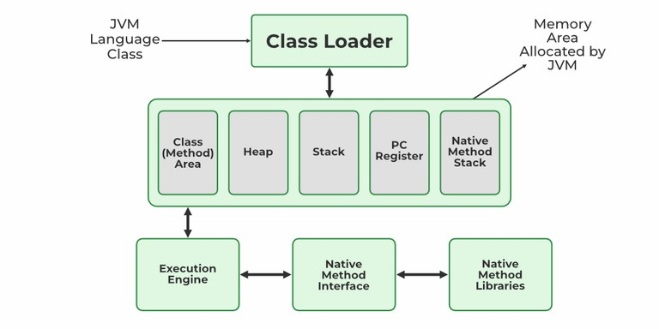
- Explain public static void main(String args[]) in Java.
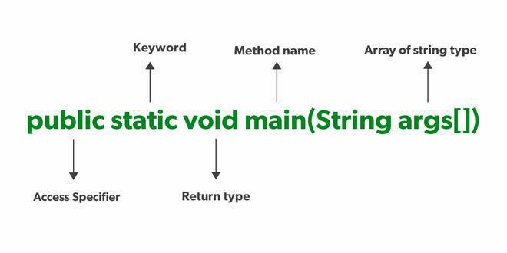

- What are the Memory Allocations available in Java?
Java has five significant types of memory allocations.
- Class Memory
- Heap Memory Stack Memory
- Program Counter-Memory
- Native Method Stack Memory

8. Java Exception Hierarchy
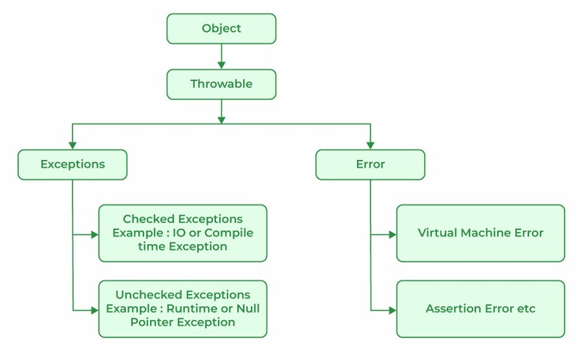

WORK DAIRY

Day 1:On the first day, ther focus in on understading the project scope and learning objectives. The primary goal is to create a Website Research similar websites other ideas and create a detailed project plan.
Day 2-5: The second day is dedicated to learning the fundamentals of Java.
- Install Java Development Kit (JDK): Download and install the latest JDK on your system.
- Choose an IDE: Select an IDE like Eclipse or IntelliJ IDEA to write and run your Java code.
- Hello World Program: Write your first "Hello World" program to familiarize yourself with basic syntax and structure.
- Data Types and Variables: Learn about primitive data types (int, float, boolean, etc.) and how to declare and initialize variables.
- Operators: Practice using arithmetic, logical, and comparison operators.
Day 6-9: Learning Object-Oriented Programming (OOP) Concepts
- Classes and Objects: Learn about classes as blueprints for objects, defining attributes (variables) and methods (functions).
- Object Instantiation: Create objects from classes and interact with their methods.
- Encapsulation: Understand the concept of data hiding by using access modifiers (public, private).
DAY 10-13:Inheritance and Polymorphism
- Inheritance: Learn how to create new classes based on existing ones (parent/child relationships) to reuse code.
- Polymorphism: Explore how objects of different classes can be treated as the same type based on the context.
- Method Overriding: Understand how to redefine methods inherited from parent classes.
- Arrays: Learn to store and manipulate collections of data using arrays.
- Collections Framework: Explore different collection types like ArrayList, HashMap, HashSet, etc., and their usage based on requirements.

DAY 14-19: Advanced Topics and Projects
- Exception Handling: Learn about try-catch blocks to handle errors gracefully.
- File I/O: Practice reading and writing data to files.
- Multithreading: Understand how to run multiple threads concurrently for improved performance.
- GUI Development (Optional): Explore Java Swing or JavaFX to create graphical user interfaces.
Benefits of Java:
One of the biggest benefits of Java is its ease of use. Because Java is an object-oriented language, it is easy to learn and write code in. Additionally, Java's platform independence makes it easy to deploy programs across multiple devices and operating systems. Java is also known for its speed and performance, which is why it is often used in high-performance applications like gaming and financial systems.
CONCLUSION:
- Java is a versatile programming language that can be used to create mobile apps, enterprise software, and more
- Java is a good choice for teaching object-oriented programming because it's less complex than C++
- Java is a good choice for introductory computer science courses because it provides compile-time error checking and can introduce students to GUI programming and networking
- Java is used across platforms and devices, from smartphones to smart TVs

BIBLIOGRAPHY:
http://www.w3schools.com http://www.wikipides.com
http://www.programiz.com http://www.geeksforgeeks.com

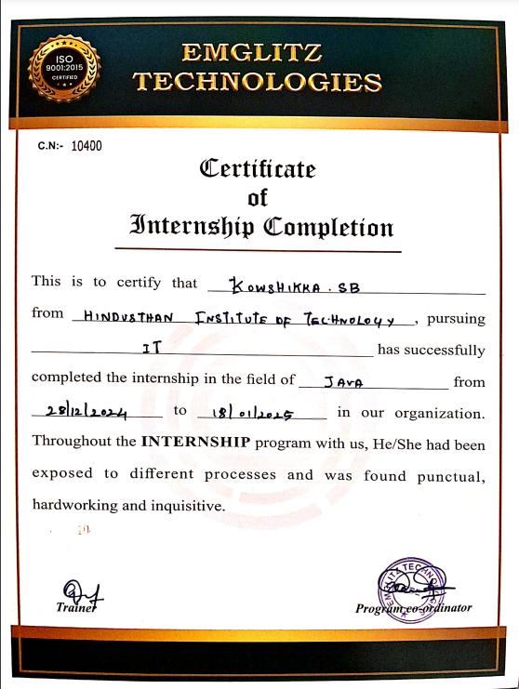

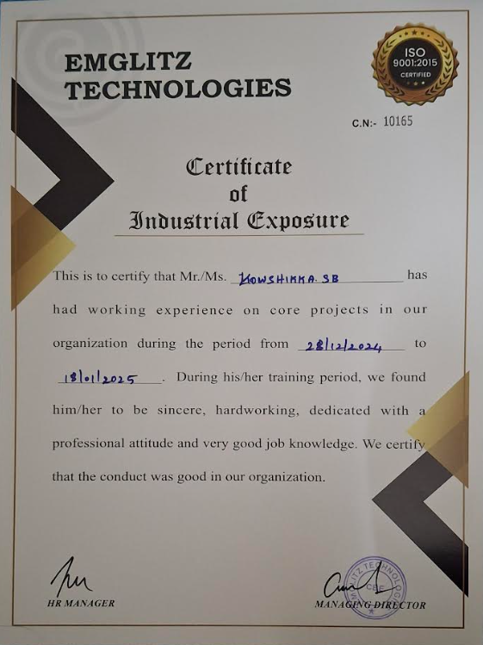

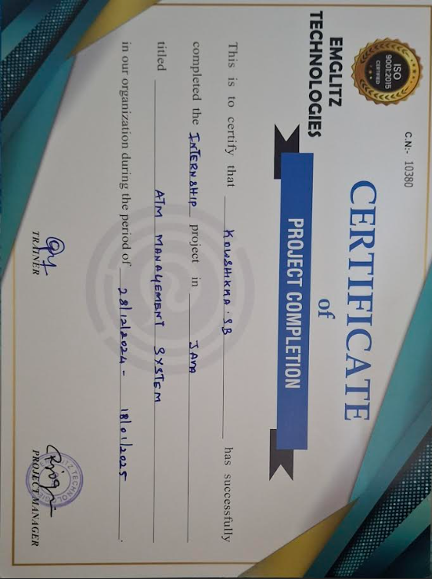

STUDENT INTERNSHIP DAILY REPORT
AND FEEDBACK
Name of student : KOWSHIKKA S B
Register Number : 720823106046
Batch/Class : 2023-2027 Batch-2nd year IT
Name of the : EMGLITZ TECHNOLOGIES PVT LTD,
Industry/Company SAIBABA COLONY,COIMBATORE
Department(in which : Java Programming
The training has been
done)

Name of the Mentor : LOGESHWARI
(company)

Mentor’s E-mail ID : info@emglitz.com &
& Contact Number 6282720685

